# Mobile Project Report

## The App

Explanation of app with innovative research elements that differentiate app from others.

Planda, meaning Plants in Irish, is an app that allows users to log and track the various plants they own.

The app allows users to check the light level of an area of their choice, some areas of a home may be too dark for example, or another example is let’s say a south-facing window may yield too much light for some plants. This feature ‘sheds light’ on new plant owners who may not be aware of the adverse effect excessive light levels can have on their plants.

The App stands out in comparison to other apps as it has a very natural, fluid UI. The app begins with an animated splash screen and then leads into a series of introductory fragment slides which introduce the user to the app one piece of information at a time. The user can also skip these introduction slides if they wish. Various toast messages are used throughout the app to confirm to the user what is happening as they select the various options. These introduction slides also use a fluid motion when moving from one to the next. This is implemented using the liquid swipe functionality by Curberto.

This app was build using galaxy flip 3 emulator but is designed to be compatible with all sizes.

Features in the app:

* Animations
* Register/Login
* Use of Kotlin as well as Java.
* Camera
* Light Sensor

## Google Play Store Resources

* 1. Title of the app: **Planda**
  2. Short description of the app: **An beautifully designed app that enables users to track their plants progress.**
  3. Full description of the app : **Planda is a beautifully designed app with the needs of the plant owner in mind at all times. This app is for plant owners, made by plant owners.**

**The features in this app include ability to take a picture of your plant to track their progress. The ability to measure the light in a given area of your home to determine if the light presence is too harsh or too low for the plant you wish to store there. The user can also register and login with authentication done by Firebase.**

**If you are interested in becoming a beta tester please email** [**support@planda.com**](mailto:support@planda.com)

**If you be interested in becoming a translation contributor please reach out to** [**translate@planda.com**](mailto:translate@planda.com)

**Current translations:**

**English**

**French**

**Japanese**

**Please rate 5 stars.**

* 1. Screenshots of the app on a phone / tablet (real device) - JPEG or 24-bit PNG (no alpha). Min length for any side: 320px. Max length for any side: 3840px.

Below is a sample of screenshots from a real device.

* + 1. Hi-res icon - 512 x 512, 32-bit PNG (with alpha)

* + 1. Feature Graphic : 1024 w x 500 h, JPG or 24-bit PNG

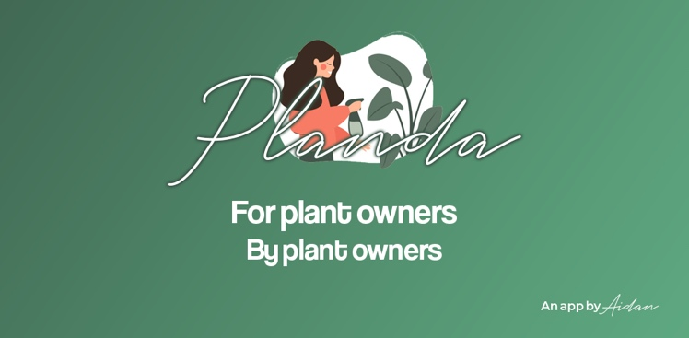

1024 x 500 PNG

## Features

Features in this app include Camera, Light Sensor, Login/Register.

## Internationalisation

This app was translated from English into French and Japanese.

## Challenge

The extra challenge undertaken in this project is building one of the activities using the Kotlin language. This was a great chance to experience what could be considered as the way forward for Android App Development. There were animations used throughout the project too.